Job Description

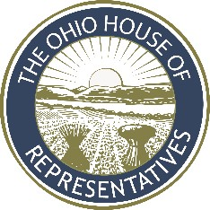**Title:** Minority Policy Advisor

**Reports to:** Minority Chief of Staff / Minority Policy Director

**Summary of Position:** Researches and analyzes legislation for members of the Minority Caucus. Works closely with and under the direction of the Minority Chief of Staff and Minority Policy Director.

# Essential functions include:

1. Researches, analyzes and summarizes bills, amendments and legislative topics
2. Provides talking points for members
3. Consults with legislators, legislative staff, and Legislative Service Commission staff on legislative policy issues
4. Prepares miscellaneous computer and database assignments
5. Provides information and works with lobbyists and employees in other legislative and government offices and agencies
6. Completes additional tasks as assigned by the Minority Chief of Staff or one of the caucus directors

# Knowledge Skills and Abilities:

* + Understands legislative process and terminology
  + Understands state government
  + Conducts legislative and policy research
  + Communicates effectively both orally and in writing
  + Multitasks and prioritizes work to meet deadlines
  + Ensures confidentiality while handling politically sensitive work

# Minimum Qualifications:

* + Bachelor’s degree
  + One year of relevant work experience