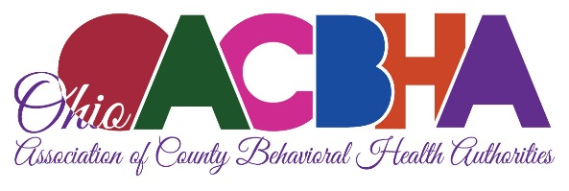

**Director of Public Policy**

**Ohio Association of County Behavioral Health Authorities**

The Ohio Association of County Behavioral Health Authorities (OACBHA) is seeking a dynamic and experienced **Director of Public Policy** to join our team. This position offers a unique opportunity to shape behavioral health policy in Ohio and advocate on behalf of our member Alcohol, Drug Addiction, and Mental Health (ADAMH) Boards.

**About the Role**The Director of Public Policy will lead OACBHA’s efforts to influence and advance sound public policy at both the state and federal levels. This includes:

* Developing and implementing strategies to engage policymakers, stakeholders, and partners.
* Analyzing and responding to legislative and regulatory proposals.
* Building and maintaining strong relationships with key decision-makers.
* Advocating for the priorities and needs of Ohio’s community behavioral health system.

**What We’re Looking For**The ideal candidate will bring:

* Proven experience in policy analysis, development, and advocacy.
* Strong knowledge of state and federal legislative and regulatory processes.
* Excellent written and verbal communication skills, with the ability to convey complex issues clearly.
* A collaborative, flexible, and energetic approach.
* Creativity, forward-thinking, and a commitment to high-quality service.
* Knowledge of Ohio’s behavioral health system is preferred.

**Qualifications**

* Minimum of a bachelor’s degree.
* At least five years of relevant experience in public policy, government, or a public/non-profit organization.

**Compensation & Benefits**

* Starting salary: **$80,000+**, commensurate with experience.
* Comprehensive benefits package.
* Hybrid work opportunities and a collaborative team environment.

OACBHA is an **Equal Opportunity Employer (EOE).**

All interested individuals should submit a resume and references to the Ohio Association of County Behavioral Health Authorities. (OACBHA) at 175 S. Third Street, Suite 900, Columbus, Ohio 43215, or by email to [sflorio@oacbha.org](mailto:sflorio@oacbha.org) by October 3, 2025.