

March 25, 2025
The Honorable Brian Stewart
77 South High Street
13th Floor
Columbus, OH. 43215

The Honorable Melanie Miller
77 South High Street
12th Floor
Columbus, OH. 43215
Dear Chair Brian Stewart and Chair Melanie Miller,
We want to express to Chair Miller our sincere appreciation for her leadership in facilitating the recent testimony from the Haslam Sports Group before the House Arts, Athletics, and Tourism Committee. Their presentation provided a compelling vision for sports-related economic development in Ohio. However, as we consider the potential inclusion of this proposal in the state operating budget, there are significant, unresolved fiscal questions that warrant further examination before any commitments are made.
The proposed funding structure places $1 billion of taxpayer obligations at stake over the life of the debt, yet critical aspects of the financial analysis remain unclear. It was not sufficiently emphasized during the presentation or subsequent questioning that these are General Revenue Fund dollars—meaning the full fiscal responsibility ultimately falls on the State of Ohio and its taxpayers. Beyond the initial $38 million in private funding, the balance of the financial risk is borne entirely by the state, with no guarantees from HSG or future developers. Given the magnitude of this commitment, we must ensure a thorough and independent review of the financial assumptions underpinning this project.
Adding to these concerns, it should not be overlooked that local elected officials—including those representing Cleveland—have expressed opposition to this project. When the officials closest to the impacted communities argue that the financial projections are unrealistic and the economic benefits are overstated, it should give us serious pause before moving forward. Their opposition suggests a lack of confidence in the assumptions underlying this proposal, further underscoring the need for independent verification of the numbers.
Additionally, we need a clearer understanding of the financial projections related to attracting additional sporting and entertainment events. While the new stadium is likely to bring some benefit in this regard, there is also an inevitable shifting of current sports and entertainment events from other venues. For example, there has been discussion about moving all the state high school football championship games to the proposed domed stadium. If that happens, would the associated economic activity currently in Canton be classified as “new revenue” and included as part of the dedicated revenue stream? If so, that would not represent new economic growth but rather a redistribution of existing revenue. Again, understanding the consultant’s analysis and assumptions is critical before we commit taxpayer dollars to this project.
Moreover, although the media has reported on a draft amendment related to the proposal, the language has not yet been widely circulated among members for review. To date, we have only seen broad concepts rather than a specific legislative framework. While some of the concerns raised may be addressed in the formal text, we cannot be certain until we see the actual details. Before we consider including this in the state operating budget, we must have the opportunity to carefully review the legislative language and hear from additional witnesses to fully understand the implications for taxpayers. A proposal of this magnitude should not be rushed or inserted as an amendment to a larger budget bill without the necessary due diligence. We have a responsibility to our taxpayers to ensure transparency and fiscal responsibility in this process.
To that end, I respectfully request that we hold additional hearings to address the following unresolved concerns:
1. State Financial Review: The testimony suggested negotiations had taken place with "the state," but it remains unclear with whom these discussions occurred. The Ohio Office of Budget and Management (OBM) and the Ohio Department of Taxation should be invited to testify before either the House Arts, Athletics, and Tourism Committee or the House Finance Committee to confirm whether they have conducted independent analyses of the financial projections. Are they comfortable with the assumptions used? Further, do they have an opinion on their validity? Additionally, do they have an opinion on the marketability of the bonds and the potential credit rating impact on such a bond issuance? And have they assessed the long-term fiscal impact on Ohio's taxpayers?
2. Consultant Assumptions & Revenue Projections: The financial projections rely on a so-called "designated revenue stream," yet there is no precise definition of what constitutes "new revenue." If existing state revenues from the Cleveland Browns' current downtown operations—such as income and sales taxes—are included in this calculation, this could effectively create a net revenue loss for the state. The consultants who prepared the financial analysis should be required to present their assumptions in detail and answer questions before a committee.
3. Legislative Services Commission (LSC) Review: To date, the Legislative Services Commission has not conducted an independent impact analysis of this proposal. Given the substantial taxpayer exposure, LSC should provide a formal fiscal review.
4. Mischaracterization of TIF Financing: The proposal has been described as a "TIF" (Tax Increment Financing) structure, yet this characterization is inaccurate. Traditional TIFs involve property owners making payments, whereas this financing plan places direct responsibility for debt repayment on the state. Clarification on this distinction is critical.
5. Infrastructure and Additional State Costs: The proposal does not account for the potential costs of reconfiguring highways and other transportation infrastructure to support the project. Who will be responsible for these costs—the State of Ohio or other entities? Additionally, does the financial analysis consider pending tax policy changes, including proposals to eliminate the state income tax? If income tax revenues are a core component of the repayment structure, how will changes to Ohio’s tax code affect long-term projections?
6. Mixed-Use Development Considerations: The development plan includes residential housing. Will the income taxes of new residents be counted as "new revenue" for purposes of repayment? If so, does the analysis assume that all residents would be moving from out of state? Otherwise, this could represent a revenue shift rather than true economic growth. Additionally, will future developers seek additional tax incentives from the state and local governments? If so, what is the estimated cost?
With so many unanswered questions, we must take the time to conduct a more rigorous review of these financial assumptions. When both independent experts and local officials voice skepticism about the viability of a project, we must take those concerns seriously. We should not proceed until we have additional hearings and hear directly from OBM, the Ohio Department of Taxation, LSC, and the consultants who prepared the financial analysis. Relying solely on a single study conducted by an outside consultant—whose client stands to benefit from the project—is simply too risky for Ohio taxpayers.
Again, we appreciate the leadership and willingness to engage in these important discussions. We look forward to working with you and our colleagues to ensure that any investment of state funds is made with full transparency and fiscal responsibility.
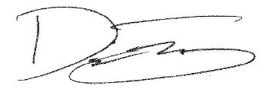
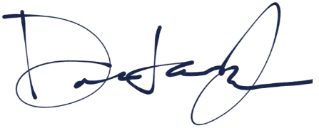
Sincerely,

Dontavius L. Jarrells Dani Isaacsohn
Assistant Minority Leader Minority Whip
1st House District 24th House District
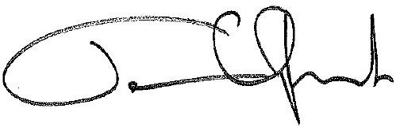

Terrence Upchurch
State Representative
20th House District

cc: Kimberly Murnieks, Director of the Office of Budget and Management
Patricia Harris, Tax Commissioner, Ohio Department of Taxation

